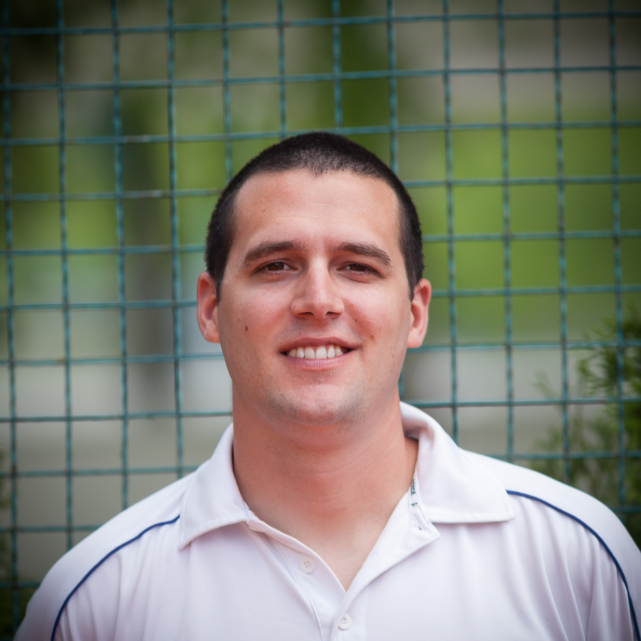

FILIP ŽIVKOVIĆ

MOBILE: +381 63 270421
Email: fzivkovic@yahoo.com
QUALIFICATIONS

12 Years of Coaching Tennis Juniors
C Coaching License – Serbian Tennis Federation
High degree of tennis teaching - University of Belgrade (sports and physical education)

PROFESSIONAL EXPERIENCE

2013 – present Head assistant coach at Tennis Institute of Belgrade, Belgrade, Serbia
2005 - 2013 Freelance Tennis Coach, worked as a personal coach with many top juniors in Serbia
2002 - 2005 Played professionally on the ITF circuit
1998 - 2001 Junior Tennis Player, best ETA ranking 46

